'Programmer: Samantha Naini
'Exercise: 6-1-30 pg. 228
'Date: 4/5/2012
'Program purpose: Illustrate the growth of money in a savings account.

Option Strict On
Option Explicit On

Public Class frmInterest

Private Sub btnDetermine_Click(ByVal sender As System.Object, ByVal e As System.EventArgs) Handles btnDetermine.Click
Dim IntRate, Amount, TwiceAmount, numYears As Double

Amount = CDbl(txtAmount.Text)
IntRate = CDbl(txtRate.Text) / 100

TwiceAmount = Amount * 2

Do While Amount < TwiceAmount

Amount = (1 + IntRate) * Amount

numYears += 1
Loop

txtDouble.Text = CStr("" & numYears & "")

End Sub

Private Sub btnClear_Click(ByVal sender As System.Object, ByVal e As System.EventArgs) Handles btnClear.Click
txtAmount.Clear()
txtAmount.Focus()
txtRate.Clear()
txtDouble.Clear()
End Sub

Private Sub btnEnd_Click(ByVal sender As System.Object, ByVal e As System.EventArgs) Handles btnEnd.Click

If MsgBox("Do you really want to quit?", MsgBoxStyle.YesNoCancel, "End Program") = MsgBoxResult.Yes Then
Me.Close()
End If

End Sub
End Class
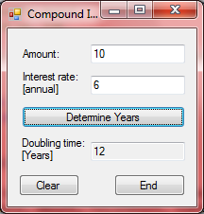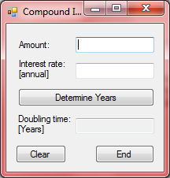←clear button
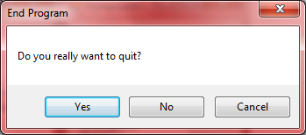←end button
'Programmer: Samantha Naini
'Exercise: 6-1-32 pg. 229
'Date: 4/5/2012
'Program purpose: Calculate when the population will grow to 10 billion.

Option Strict On
Option Explicit On

Public Class frmPopulation

Private Sub btnCompute_Click(ByVal sender As System.Object, ByVal e As System.EventArgs) Handles btnCompute.Click

Dim pop, year As Double

pop = 6.83
year = 2010

Do While pop < 10

pop = pop + (0.0112 * pop)

year = year + 1
Loop

txtAnswer.Text = CStr("" & year & "")
End Sub

Private Sub btnClear_Click(ByVal sender As System.Object, ByVal e As System.EventArgs) Handles btnClear.Click
txtAnswer.Clear()
End Sub

Private Sub btnEnd_Click(ByVal sender As System.Object, ByVal e As System.EventArgs) Handles btnEnd.Click
If MsgBox("Do you really want to quit?", MsgBoxStyle.YesNoCancel, "End Program") = MsgBoxResult.Yes Then
Me.Close()
End If

End Sub
End Class
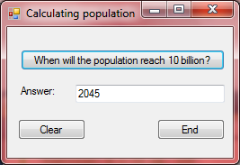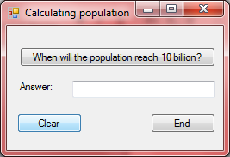←clear button
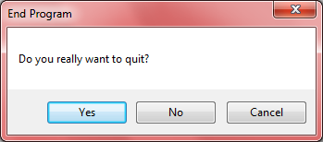←End button

